Helping You to Understand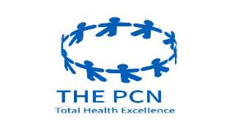
Primary Care Networks (PCNs)
Primary Care is the healthcare you get from your local GP and most other health services provided out in the community, in surgeries, clinics and your own home.

A Primary Care Network (PCN) is a small group of GP practices, working together with other community services, mental health, social care, pharmacy, hospital, and voluntary services in their local areas, to effectively meet the health and social care needs of an increasing population. Collectively these agencies can offer better support for people who need short term care or those who are living with long term conditions.
There are 1,250 PCNs across England, typically serving between 30,000 to 50,000 people. They are small enough to provide care according to the identified local populations’ needs but large enough to have a beneficial impact.
PCNs work with all partners to provide proactive, personalised health and social care for people close to home. Each PCN is led by a clinical director who may be a GP, general practice nurse, clinical pharmacist, or other clinical professional working in general practice.

What Primary Care Network does your surgery belong to?

Pencester Surgery is part of East PCN and other surgeries that make up the East PCN are:
- Aylesham Health Centre
- Whitecliffs Medical Centre
- Lydden Surgery
Collectively your PCN practices have a population of 37,841 patients

Your Primary Care Network (East PCN) works collaboratively with the West PCN and their 4 practices and they are collectively known as Total Health Excellence between them they have a combined population of 80,737

